./

Learning Report – Applied System Development Life Cycle and Software Testing



|  |  |  |  |  |  |
| --- | --- | --- | --- | --- | --- |
| **Ver. Rel. No.** | **Release Date** | **Prepared. By** | **Reviewed By** | **To be approved By** | **Remarks/Revision Details** |
| 1 |  | Name/PS No | Name/PS No | Module Owner Name | Comments |
| 2 | 15/02/21 | Shivanshu/99003731 |  |  |  |
| 3 |  |  |  |  |  |
|  |  |  |  |  |  |
|  |  |  |  |  |  |

**Document History**

Table of Contents

Table of Figures 3

Table of Tables 4

ACTIVITY 1: SYSTEM/ SOFTWARE DEVELOPMENT 4

**INTRODUCTION** 4

**MY PRODUCT: “Name ”** 6

**SWOT ANALYSIS** 7

**REQUIREMENTS** 7

**DESIGN** 8

HIGH LEVEL DESIGN 8

LOW LEVEL DESIGN 11

**TEST PLANS** 13

**REFERENCES** 15

ACTIVITY 2: AGILE METHODOLOGY 15

**THEME** 15

**EPIC** 15

**USER STORY** 16

**REFERENCES** 17

APPENDIX: 17

## Table of Figures

Figure 1 CLASS DIAGRAM(HIGH LEVEL) 10

Figure 2 DEPLOYMENT DIAGRAM(LOW LEVEL) 12

Figure 3 USE CASE DIAGRAM (LOW LEVEL) 12

Figure 4 TEST PLAN 25

Figure 5 GIT 27

Figure 6 GIT ISSUES 28

Figure 7 GIT COMMITS 28

Figure 8 GIT 30

Figure 9 GIT MAKE 31

Figure 10 GIT BUILD 32

Figure 11 GIT CODE QUALITY 32

## Table of Tables

Table 1 AGING 6

Table 2 GRADING COST 6

Table 3 REQUIREMENTS 8

Table 4 HIGH LEVEL TEST PLAN 15

Table 5 LOW LEVEL TEST PLAN 16

Table 6 USER STORIES 17

Table 7 AGING 19

Table 8 GRADING COST 19

Table 9 REQUIREMENTS 21

Table 10 USER STORIES 27

# Requirements

## Introduction

This is a multi-purpose low cost scientific calculator which has near about 4-5 new modes compare to the scientific calculator which already in the market. We have added physics operation, matrix operations, profit loss, finance, permutation and combination, mensuration etc.

## Research

**Cost Vs Feature Curve**

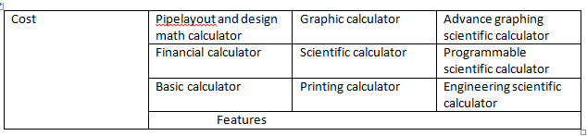

## Cost and Features (Our system)

**1.Cost is near about 1000-1500 Rs**

***2.Features included***

1. Basic arithmetic operation
2. Physics operation
3. Matrix operations
4. Combinatorics operations
5. Mensuration
6. Profit and Loss operation
7. Combinatorics (permutation and combination)
8. Finance’s operation
9. Special Math Functions (Exponential, Trigonometric, logarithmic)

## SWOT ANALYSIS

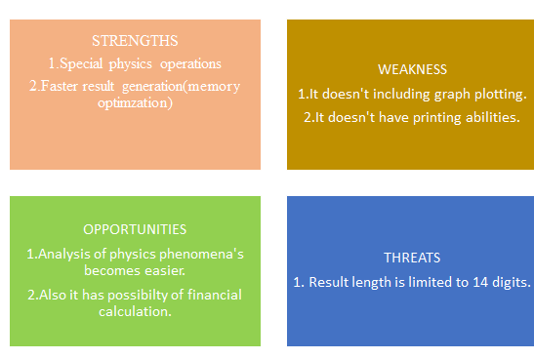

# 4W's and 1'H

## Who:

**Generally businessman, engineers ,students and scientist uses calculator but they use different calculator for each purpose.**

## What:

**There are already so many types of calculator that exist in the market already for making our life easier. Few of the calculators we have researched are basic calculator, scientific calculator, financial, graphing ,printing calculator etc.**

## When:

**This requirement of this type of calculator started because firstly manual calculations are difficult.**

## Where:

**It can be used for design analysis of various mechanical equipment’s such as spaceships, vehicle’s speed and diagnostic analysis etc.**

## How:

**We are going to make functions the necessary physics phenomena’s which are difficult to calculate manually.**

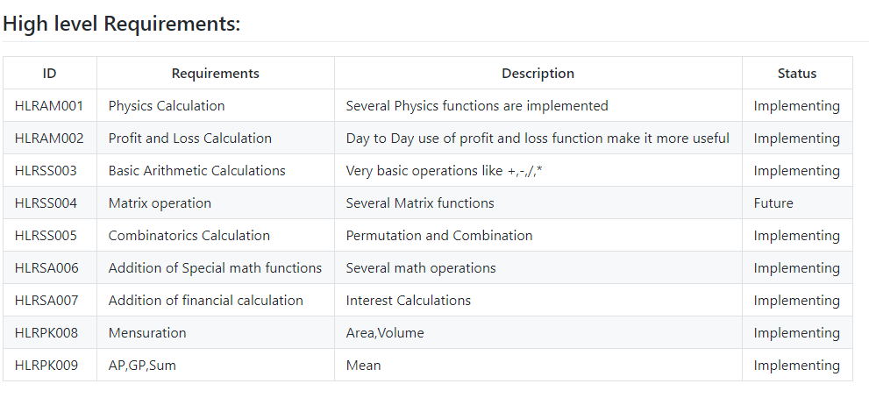

**LOW LEVEL REQUIREMENTS**

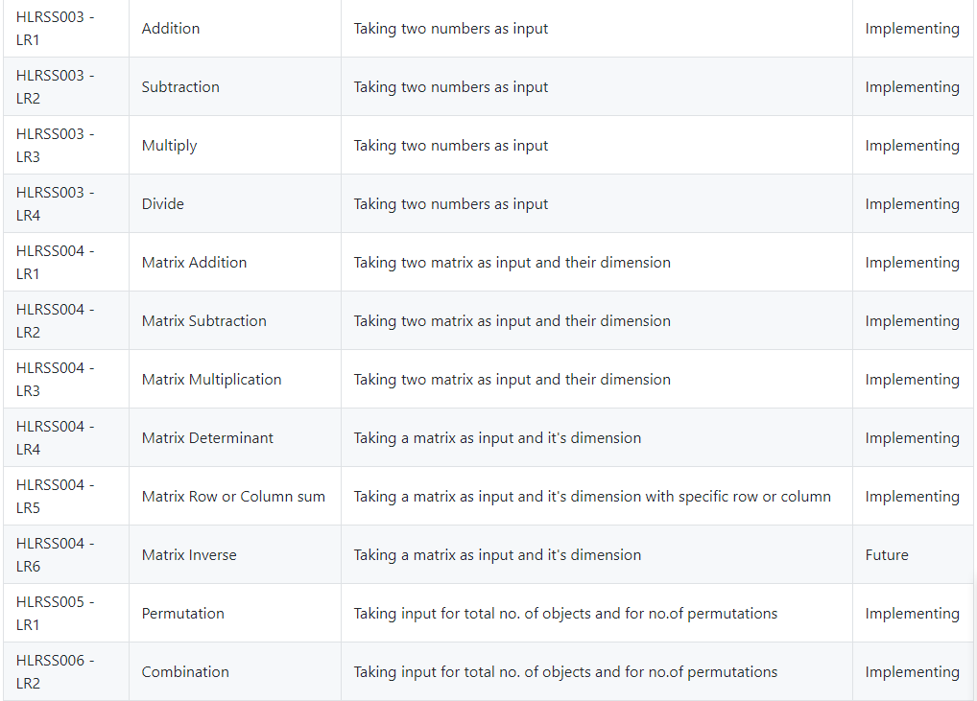

**DESIGN (UML DIAGRAM)**

1. **CLASS DIAGRAM(HLR)**

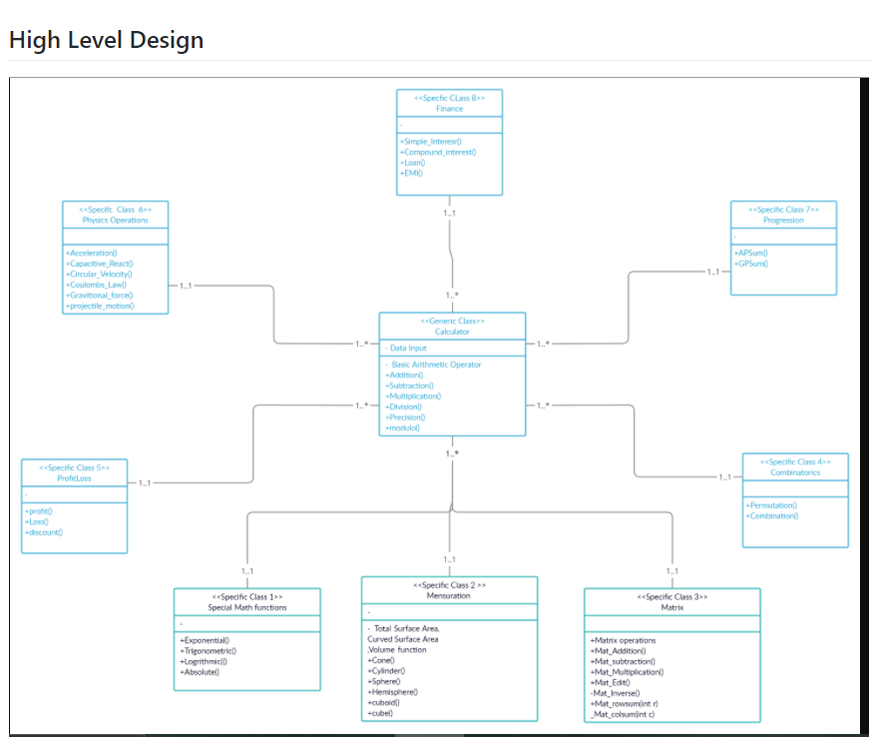

1. **DEPLOYMENT(LLR)**

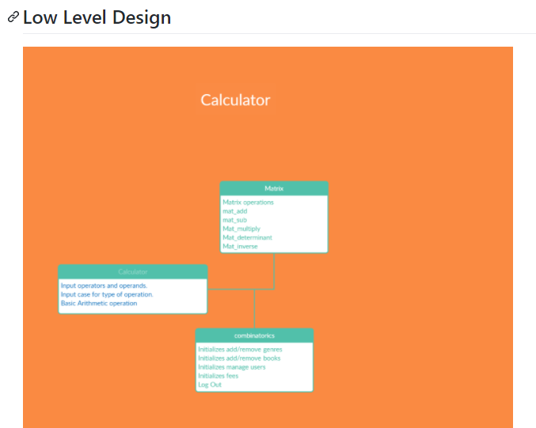

**3.USE CASE(LLR)**

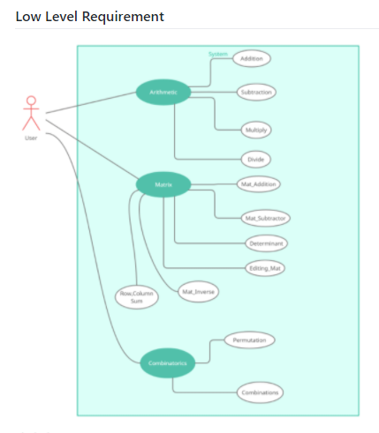

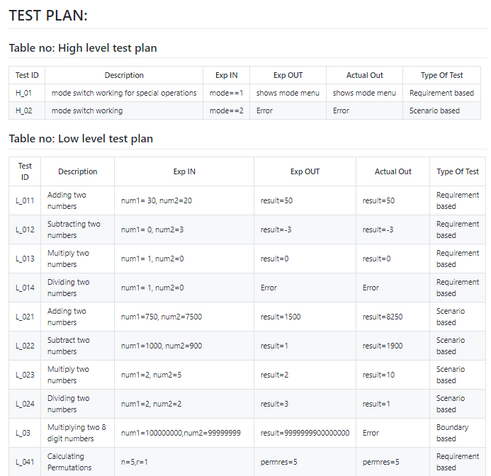

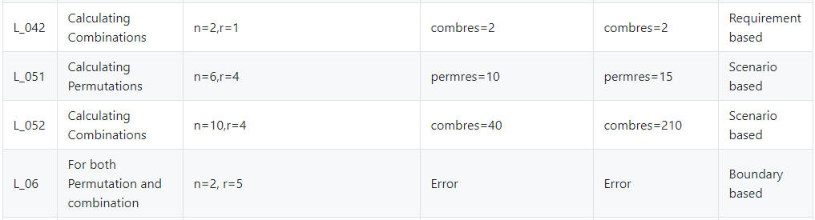

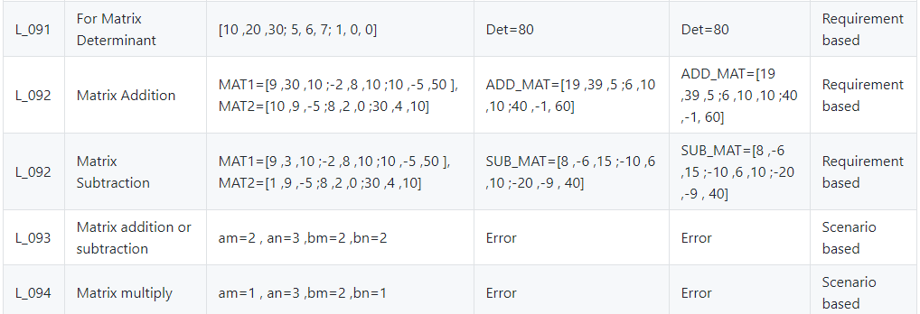

**GIT ISSUES**

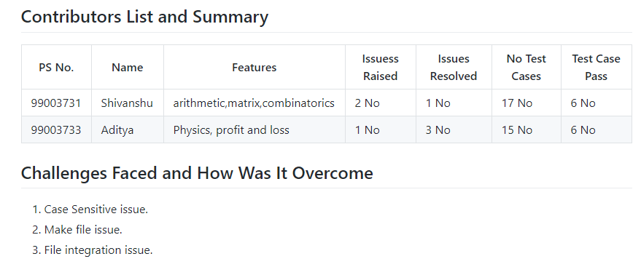

**GIT COMMITS**

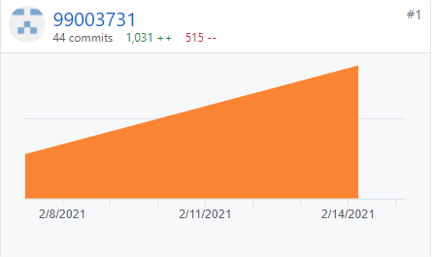

**GIT CODE QUALITY(CPP CHECK)**

